**Course Approval :**

**Certificate Earn:**

****

**2nd Week Progression**

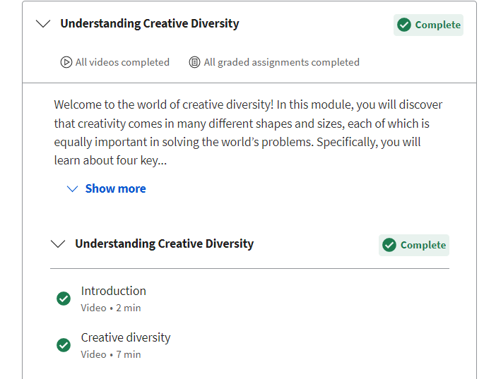

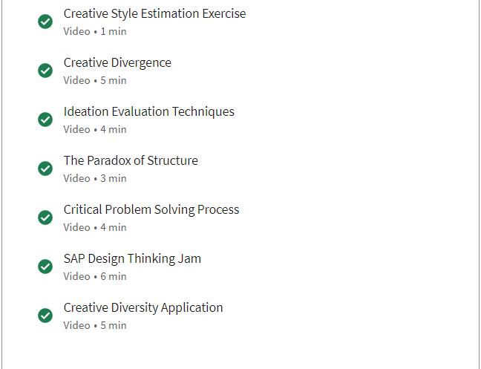

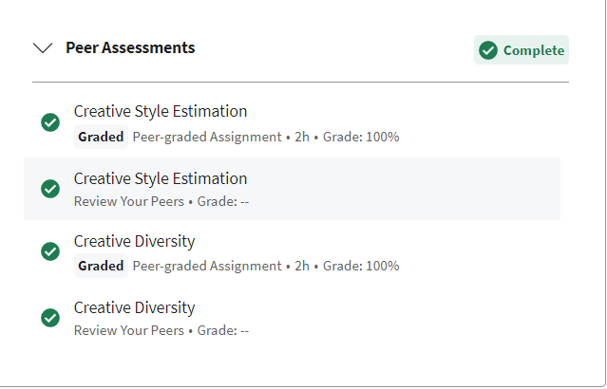

**Notes**

***Notes of week 2***

* **Introduction**

The world is full of problems that are complex and challenging. They cannot be solved by one person or one kind of idea or an approach. We have people learning in different Ways. We have teachers teaching in different ways. And all of that is necessary in order for people to best education they can. So, we need Creative Diversity to survive and thrive.

* [**Cre**](https://www.coursera.org/learn/creativity-innovation/lecture/rdnhX?t=0)**ative Diversity**

**Your Notes**

.Creative diversity can also refer to the variety of creative fields and disciplines. From visual arts to music, writing, and even coding, creativity can take many forms, and individuals from different fields can learn from each other and inspire new approaches and techniques. When people from different backgrounds and with different experiences come together to collaborate, they can create something truly unique and groundbreaking. Types of Myths: 1. Only some people are creative. 2. Only some kinds of ideas are creative. Four Principles of creative diversity model : 1. Everyone is creative 2. We're not all creative in the same way. 3. Describing or creative diversity using four variables: a) Creative level b)Creative style c) Motive d) Opportunity

* **[Creative Divergence](https://www.coursera.org/learn/creativity-innovation/lecture/rdnhX?t=0" \t "_blank)**

**Your Notes**

Convergent thinking and divergent thinking are two important concepts in the field of creativity. Convergent thinking refers to the process of narrowing down possibilities to find a single correct solution to a problem. It involves analyzing and evaluating information to arrive at a logical conclusion. Convergent thinking is important in many fields, such as science, mathematics, and engineering, where there are often clear-cut solutions to problems. Divergent thinking: was about coming up with multiple solutions , multiple ideas, multiple alternatives. Convergent thinking: was when you narrowed down your choices. Divergence is about multiple options, convergence is about choosing from those options. Some people have taken the above original definitions and turned them into something that doesn't make sense, a myth. And that myth says that only certain people use divergent thinking, and other people only use convergent thinking. Another myth is that divergent thinking is only about the out-of-the-box revolutionary stuff.

[**The Paradox of Structure**](https://www.coursera.org/learn/creativity-innovation/lecture/rdnhX?t=0)

**Your Notes**

Michael Curtin Introduced the paradox of the structure. The paradox of structure refers to the tension between the need for structure and the need for flexibility in the creative process. On one hand, the structure provides a framework that guides and directs creativity. It helps to organize ideas, set goals, and establish boundaries. On the other hand, too much structure can stifle creativity by limiting the range of possibilities and restricting the freedom to explore new and unconventional ideas. To navigate the paradox of structure, it is important to strike a balance between structure and flexibility. A structured approach can help to set goals, establish a timeline, and provide a framework for generating and evaluating ideas.

* [**SAP Design Thinking Jam**](https://www.coursera.org/learn/creativity-innovation/lecture/rdnhX?t=0)

Design thinking incorporates IFF (Intelligent Fast Failure). It incorporates prototyping. It incorporates all kinds of idea techniques, both generating techniques and selecting them.

Different phases in the design thinking process are 1. Empathize 2. Define 3. Ideation 4. Prototyping 5. Testing. In the empathize mode we have to physically interact with the audience. It is the phase where we collect the data. In the define mode, we have to form the problem statement using the data that we had collected during the empathize phase. Ideation involves different types of techniques like Brainstorming. It involves generating as many ideas as possible. Group meetings are also held to generate more ideas. Now, we have to form a prototype by which audience can interact. If some problem occurs in this phase then we can redefine the problem. After confirmation of the prototype, we have to form a product.

**Discussions**

**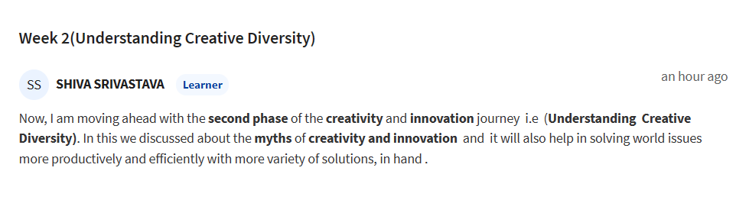**

**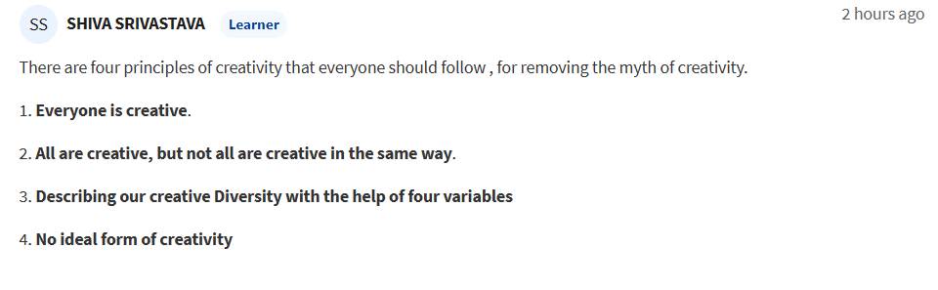**

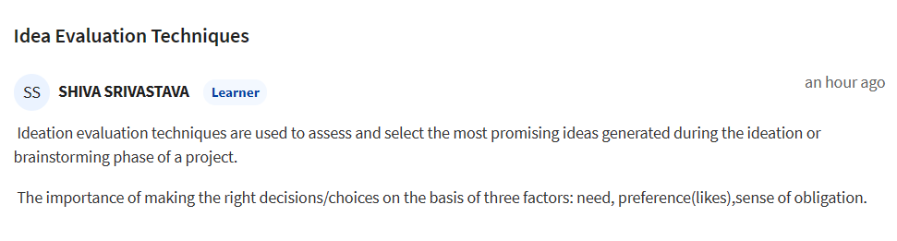

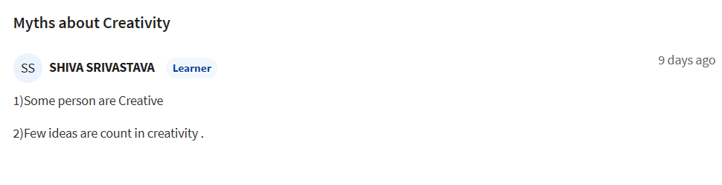

**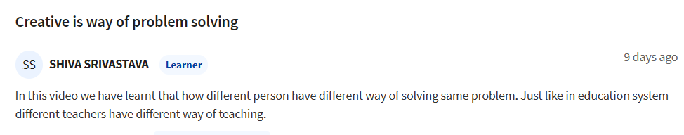**

**Peer Assessment**

***Creative Style Estimation***

**Please record your numerical Overall Result from the Creative Style Estimate survey (e.g., 35, 72**).

I got 49 in Overall result from the Creative Style Estimate Survey.

**Which of the following options (according to your survey results) describes your creative style?**

**Strongly adaptive; Moderately adaptive; Mildly adaptive; Mildly innovative; Moderately innovative; Strongly innovative**

35-40 are Mild Adaptive option describe

**Reflect on this estimate and comment on how well it describes you.**

I think my estimation is 80%.

**List at least 2 advantages of being the creative style you are. Then describe a situation in your life when your creative style helped you in some way.**

Risk taking: i am willing to take risks and more likely to come up with new and innovative ideas.

Curiosity: I am more curious and likely to explore new ideas and ask questions that can lead to innovative solutions.

Open-mindedness: I work with open-mindedness and This allows me to think critically and approach problems from different angles.

Empathy: I am empathetic to understand any problem with its root cause.

**List at least 2 disadvantages of being the creative style you are. Then describe a situation in your life when your creative style caused difficulties for you.**

Confusion: this lead to lot of confusion.

Deep learning: i always want to go in fundamental of learning.

**What insights have you gained about yourself from this exercise and these reflections?**

I think , it helps me to observe myself .

1. ***Creative Diversity***

**Submit your interview summary here**

1. Based on the interviews with Vineet , Muskan , and Ananya, it can be concluded that all three believe that everyone has the potential to be creative. However, not everyone chooses to develop or exercise their creative abilities. They also agreed that a creative product or idea should be unique, innovative, and meet a need or solve a problem. The chances of success for a creative idea depend on various factors such as timing, market demand, and execution. They also mentioned that the source of creativity can come from personal experiences, exposure to new and different things, curiosity, and a desire to improve upon existing ideas or products. Where and how did Creative Diversity show up in your interviews and discussions? Did you see evidence of different creative levels and/or different creative styles.

**1. Where and how did Creative Diversity show up in your interviews and discussions? Did you see evidence of different creative levels and/or different creative styles?**

.In my interviews with Vineet , Muskan and Ananya I did observe some evidence of creative diversity in terms of the range of creative styles and levels of creativity expressed.

For example, while all three interviewees believed that everyone has the potential to be creative, they differed in their views on how many people are actually creative. Vineet believed that all people are creative in some way, while Muskan thought that most people have the potential to be creative, but not everyone exercises that potential. Ananya believed that everyone has the potential to be creative, but not everyone chooses to develop their creativity. These varying perspectives suggest a diversity of opinions on the extent of creative potential in individuals.

Furthermore, each interviewee used different words to describe a creative person, reflecting different creative styles and perspectives. Vineet described creative people as "innovative", Ananya as "visionary", and Muskan as "unique". These different descriptors suggest different approaches to and definitions of creativity.

Overall, while the interviews did not reveal significant differences in the level of creativity expressed by the interviewees, they did suggest a diversity of perspectives and approaches to creativity

**2. How do your own views of creativity compare with those of the people you interviewed?**

we all agreed that everyone has the potential to be creative, but not everyone chooses to develop or exercise their creative abilities. We also agreed that a creative product or idea should be unique, innovative, and meet a need or solve a problem.

**3. What was the most surprising response you received to one of your interview questions?**

my interview questions were generally in line with what I would expect. However, one interviewee, Muskan, provided a somewhat unexpected response to the question about the chances of success for a creative idea. While Vineet and Ananya believed that success depends on factors such as timing, market demand, and execution, Muskan emphasized the importance of belief in oneself and persistence, stating that "if you believe in your idea and keep working on it, you can make it successful."

This response was somewhat unexpected because Muskan did not mention external factors that are commonly cited as important for success, such as market demand or execution. Instead, she emphasized the importance of personal belief and persistence in the face of obstacles. This response highlights the potential importance of mindset and attitude in achieving creative success, which is an interesting and valuable insight.